Steps I took to attempt the lab:

1. Without looking anything up, I decided on first disabling address randomization when starting my Linux session, but only for the session, not the entire system. I followed the steps provided in the link in the prompt.
   1. 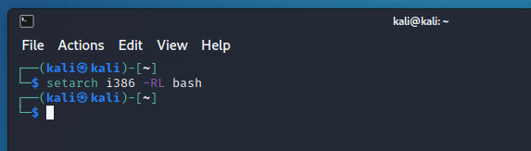
2. I copy pasted the code into the editor and saved it to my Kali desktop
   1. 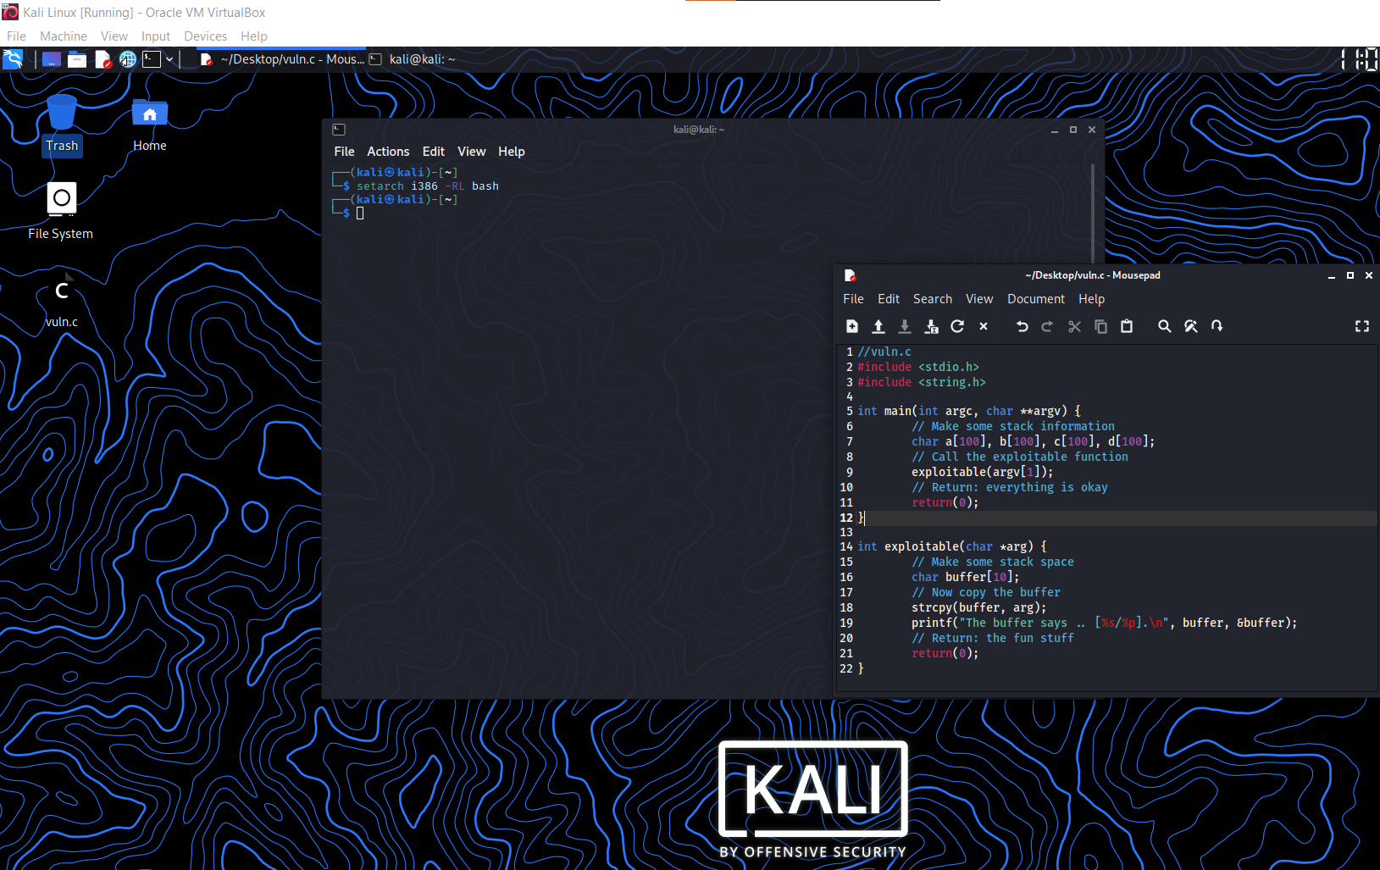
3. 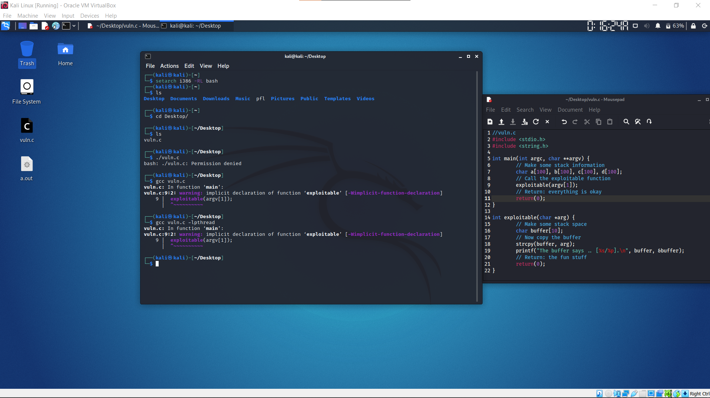
   1. I’m thinking that it’s because I didn’t include a header file, which is the purpose of the assignment, but I’m not able to figure it out